1, Introduction:
Topic: Business statistics: Use Statistic Analysis to determine Validity of Relationships
A statistics analysis is widely used in finance. In statistics, the relationship included correlation and causality. Now, we are going to use two business examples that explain how the two relationships work. The main objective in this paper is to select the suitable controlled variables in their relationships.

2, Research Goal
Use statistics to analysis the correlation relationship between oil price and the major Airlines Stock Market.
Use statistics relationship of causality to explain why Mattel went down suddenly in 2014.

3. Background
Academic background:
Correlation is a statistical measure (expressed as a number) that describes the size and direction of a relationship between two or more variables. A correlation between variables, however, does not automatically mean that the change in one variable is the cause of the change in the values of the other variable.
Causation indicates that one event is the result of the occurrence of the other event; i.e. there is a causal relationship between the two events. This is also referred to as cause and effect.
Example:
How long you teeth will be broken. It depends on how much time you spend on brushing your teeth. The time is variables. That’s correlation. However, if you mouth beaten by someone, of course, your teeth will be broken suddenly. The directly reason why your teeth broken is you are beaten. That’s causation.
There are many methods in statistics to analysis those two relationships, including regression analysis, hypothesis-test, T-test were selected to build a model of stock market. (oil price and delta, Mattel)
Regression analysis is one of the most important statistical techniques for business applications. The analyst may use regression analysis to determine the actual relationship between these variables by looking at a company’s stock price affect another company’s stock over the past several years. The regression results show whether this relationship is valid.

A statistical hypothesis is an assumption about a population parameter. This assumption may or may not be true. Hypothesis testing refers to the formal procedures used by statisticians to accept or reject statistical hypotheses.
- Null hypothesis. The null hypothesis, denoted by H₀, is usually the hypothesis that sample observations result purely from chance.
- Alternative hypothesis. The alternative hypothesis, denoted by H_{a}, is the hypothesis that sample observations are influenced by some non-random cause.
A t-test is an analysis of two population means through the use of statistical examination; a t-test with two samples is commonly used with small sample sizes, testing the difference between the samples when the variances of two normal distributions are not known.
Now, I am going to use the company named Mattel explain how the causality works. Mattel is a toy company.
Mattel (causality)
Company background: Mattel, Inc., incorporated on March 6, 1968, designs, manufactures, and markets a range of toy products around the world, including Mattel Girls & Boys Brands. Mattel runs a good business until 2014 when they announce they will lose the contract with Disney.
(1) initial data
Here we collected data from yahoo finance http://www.nasdaq.com/symbol/mat/historical from1/3/ 2012-12/31/2015

Table 1 :
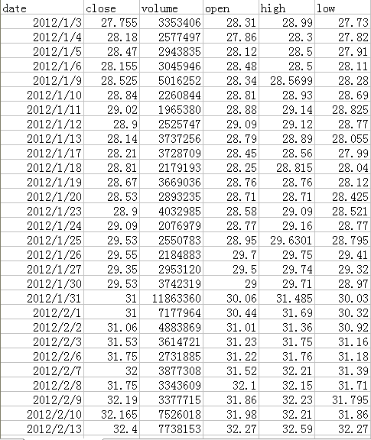
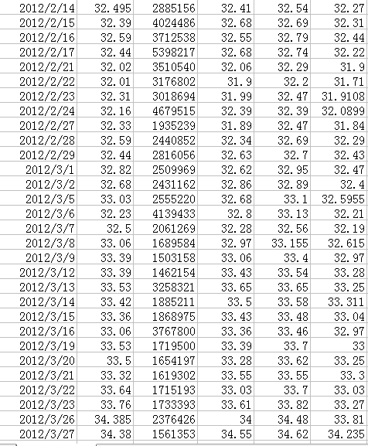

(2)Data description
Chart 1: this is the chart which the data is from 2012-2015
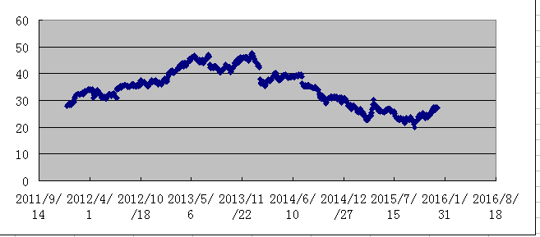
From this chart we can easy to see that it increases between 2012-2013, but why suddenly, it drop a lot after 2013, and it lasts 2 years?
Reasons, Mattel lose contract with Disney after 2013 which cased Mattel stock market dropping.
http://money.cnn.com/2014/09/25/news/hasbro-frozen-disney/
"Disney Princesses Ditch Mattel." CNNMoney. Cable News Network. Web. 01 Aug. 2016.

From 1/3/2012 to 09/25/2014, there are 686 data, and the mean value of Mattel is 38.324, and from 9/26/2014 to 12/31/2015, there are 318 data, and the mean value of Mattel is 26.348. We can easy to see that these two periods’ mean values are so much different. And also, the standard deviation is 4.746 in period one but 2.933 in second period. The standard deviations in these two periods are difference, that’s why we use T-test for two independence samples. In finance, standard deviation is applied to the annual rate of return of an investment to measure the investment's volatility. The smaller an investment's standard deviation, the less volatile it is. The larger standard deviation, the more dispersed those returns are and thus the riskier the investment is. The higher standard deviation means higher-risk, higher-yield.

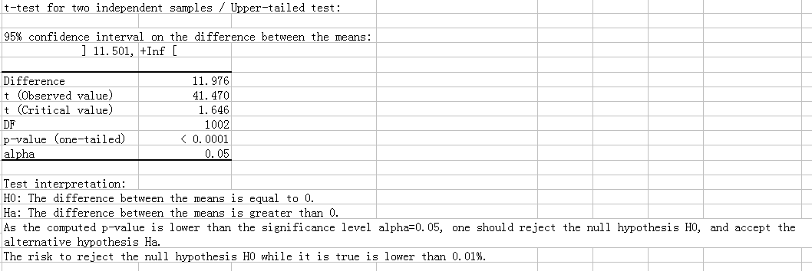

Doing the hypothesis testing:
The null hypothesis is H0: The difference between the means is equal to 0.( μ1=μ2)
The alternative hypothesis is Ha: The difference between the means is greater than 0. ( μ1>μ2)

95% of the confidence interval is our assumption, which means the significant level is 5%. The difference is between the mean value (38.324-26.348=11.976). Observed value 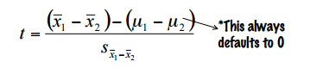

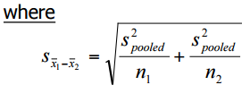

Critical value is base on the alpha and the degree of freedom (DF), alpha=0.05, DF=686+318-2=1002, so that we can check the table and find it the t critical value is 1.646. And we can get the P value is less than alpha= 0.0001. P(t>41.470)=P(x1-x2>=38.324-26.348∣( μ1=μ2)) <0.0001.
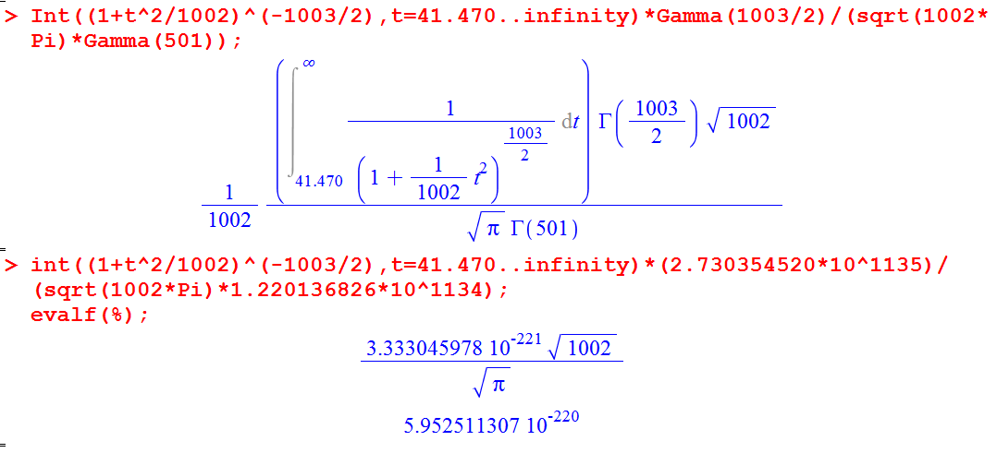
Whenμ1=μ2, the probability of getting a sample from 2nd time period has a mean difference of 11.976 or greater is much less than 0.01%, so we have strong evidence to say the difference of mean between 1st and 2nd time period is more than 0.

